Draw a UML diagram to show the relation between classes in these code fragments.
1. Draw relation between Player and Location.
public class Player {
private Location location;
public void setLocation(Location loc) {
this.location = loc;
}
// other methods
}

2. GameFactory creates a new Game, but it does have a Game attribute (no association). Show the relationship.
public class GameFactory {
public Game createGame(Level gamelevel){
// create and return a new Game
}

}

3. Show the relation between BoardGame, Game, and MultiPlayer
public class BoardGame extends Game
implements MultiPlayer {

}

4. Show relation between Game and Player, with multiplicity.
public class Game {
private List<Player> players;

}

5. Show relation between Board and Square, with multiplicity.
public class Board {
// the Board always has 64 squares
private final Square[] squares =
new Square[64];

}
6. Here's is part of a shopping application. A Sale consists of LineItems the customer is buying. Each LineItem has a quantity and a Product. For example, 3 packages of Mama Ramen is a LineItem, "Mama Ramen" is the Product. Each Product has a price (the unit price).
The getTotal( ) method of Sale should compute the total price of all LineItems in the Sale. Can you figure out how to write the code using this UML diagram?

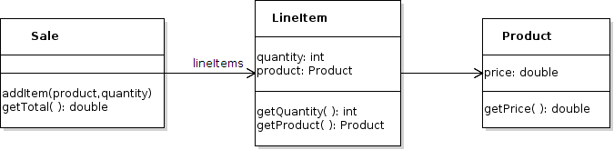

public class Sale {
/** the LineItems in this sale. */
private Collection<LineItem> lineItems;
/**
* Compute the total price of all lineItems in this sale.
*/
public double getTotal( ) {

7. Draw a Sequence Diagram for the add( ) method.
class Money {
double value;
String currency;
public Money(double value, String currency) …
public double getValue() { return value; }

}

class Main {

public Money add(Money x, Money y) {

double value = x.getValue() + y.getValue();

String curr = x.getCurrency();

return new Money(value, curr);

}
}

